Pin no:18485A0311

HAND LAY-UP PROCESS:

* Hand lay-up technique is the simplest method of composite processing.
* The processing steps are quite simple. First of all, a release gel is sprayed on the mold surface to avoid the sticking of polymer to the surface.
* Thin plastic sheets are used at the top and bottom of the mold plate to get good surface finish of the product.
* Reinforcement in the form of woven mats or chopped strand mats are cut as per the mold size and placed at the surface of mold after perspex sheet.
* Then thermosetting polymer in liquid form is mixed thoroughly in suitable proportion with a prescribed hardner (curing agent) and poured onto the surface of mat already placed in the mold.
* The polymer is uniformly spread with the help of brush. Second layer of mat is then placed on the polymer surface and a roller is moved with a mild pressure on the mat-polymer layer to remove any air trapped as well as the excess polymer present.
* The process is repeated for each layer of polymer and mat, till the required layers are stacked. After placing the plastic sheet, release gel is sprayed on the inner surface of the top mold plate which is then kept on the stacked layers and the pressure is applied
* . After curing either at room temperature or at some specific temperature, mold is opened and the developed composite part is taken out and further processed.
* The time of curing depends on type of polymer used for composite processing. For example, for epoxy based system, normal curing time at room temperatur is 24-48 hours. This method is mainly suitable for thermosetting polymer based composites.

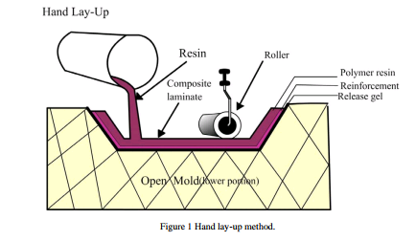

MATIRIALS USED:

Matrix:

Epoxy,polyster, polyuinyl ester,phenolic resin ,unsaturated polyster.

Reinforcements:

Glass fiber, carbon fiber ,natural plant fibers. (all these fibers are in the form of unidirectional mat, bidirectional mat stiched into a fabric)

Advantages:

* complicated equipment is not required,it needs simple mould and tools.
* This process is cheaper that means less investment.
* Production rate is less and high volume fraction.

Disadvantages:

* production efficiency is lower,the speed is slow,the production cycle is little longer.
* Production quality is not as stable machine. Because of the difference of level of operating production environment.

Applications:

Manufacturing of air craft components, automotive parts,boat hulls,diase board,deck etc.

PAKIRAPPA

Seventh revised edition